|  |  |
| --- | --- |
| chads  [TECHNICAL BRIEF] | Abstract  TABLE OF CONTENTS   * DATABASE TO QVD MAPPING * TRANSFORMED / DERIVED FIELDS * CANONICAL COLUMNS * TABLE JOINS * DATA MODEL DESIGN * QLIKVIEW SCRIPT LOGIC (EXTRACT/TRANSFORM/LOAD) * DATA VOLUME * DATA INTEGRATION * DB CONNECTION STRING INFO * EXPRESSIONS OVERVIEW * RISKS * UI LEGEND |

|  |  |  |  |
| --- | --- | --- | --- |
| **Author** | **Version** | **Revision** | **Revision Date** |
| Kushal Chawda | 1.0 | Initial Draft | 21/05/2019 |

**Technical Overview**

1. **QVD Libraries**

|  |  |  |  |  |
| --- | --- | --- | --- | --- |
| **QVD Name** | **QVD Path** | **Data connection** | **Source Table/View** | **Database** |
| gl_account_daily_aggregated_fact | \\qlikapp1\Qlik\Balance movement\Qvd\ | Balance_movement_qvd | gl_account_daily_aggregated_fact | cap_mi_test |

1. **QVD Extract**

|  |  |  |  |  |
| --- | --- | --- | --- | --- |
| **QVD Name** | **Script** | **Application Name** | **Stream** | **Data connection** |
| **gl_account_daily_aggregated_fact** | **SELECT \***  **FROM [cap_mi_test].[gl_account_daily_aggregated_fact];** | Balance movement 1.1 | Everyone | **Impala_connection** |
| **Calendar** |  |  |  |  |

1. **Transformations / derived fields:**

|  |  |  |
| --- | --- | --- |
| **Table/Column** | **Derived From** | **Logic** |
| T_vwas_assetsummary/  Total_Seats_Range | total_seats | if(total_seats = 1, dual('01 Seat',1),  if ( total_seats >= 2 and total_seats <=5, dual('02-05 Seats',2),  if (total_seats >= 6 and total_seats <=10, dual('06-10 Seats',3),  if (total_seats >=11 and total_seats <= 20, dual('11-20 Seats',4),  if (total_seats >= 21 and total_seats <=50, dual('21-50 Seats',5),  if (total_seats >= 51 , dual('51+ Seats',6))))))) as Total_Seats_Range |

1. **Additional logic for derived fields**

<Additional *transformation logic that is more complex*>

1. **Canonical Columns**

(Disparate column(s), with same data, that have been combined into 1 column for QV display and data model efficiency purposes)

1. **Table Joins**

If you have a single star schema model, list your main Fact table right at the top.

All other tables with joins to the Fact table are listed, with the join column specified.

|  |  |  |  |  |  |  |  |
| --- | --- | --- | --- | --- | --- | --- | --- |
| **T_contact_account_lead(Main Fact table)** | **Account_uuid** | **Contact_uuid** | **Marketo_id** | **mkto_marketing_channel_country** | **Asset_product_line** | **Sfdc_contact_id** | **email** |
| Product_name_rollup |  |  |  |  | Asset_product_line |  |  |
| Vwas_assetdetail |  |  |  |  |  | Software_  Coordinator_  Sfdc_id |  |
| Vwas_assetsummary |  |  |  |  |  | Software_  Coordinator_  Sfdc_id |  |
| Vwas_accountsummary | Account_uuid |  |  |  |  |  |  |
| T_supplemental_usage |  |  | Marketo_id |  |  |  |  |
| T_activities_qv |  |  | Marketo_id |  |  |  |  |
| Ecq_contact_quality |  | Contact_uuid |  |  |  |  |  |
| Ucm_s_party |  | Contact_uuid |  |  |  |  |  |

1. **Data Model Design:**

Further information on your data model, a ER diagram here would help.

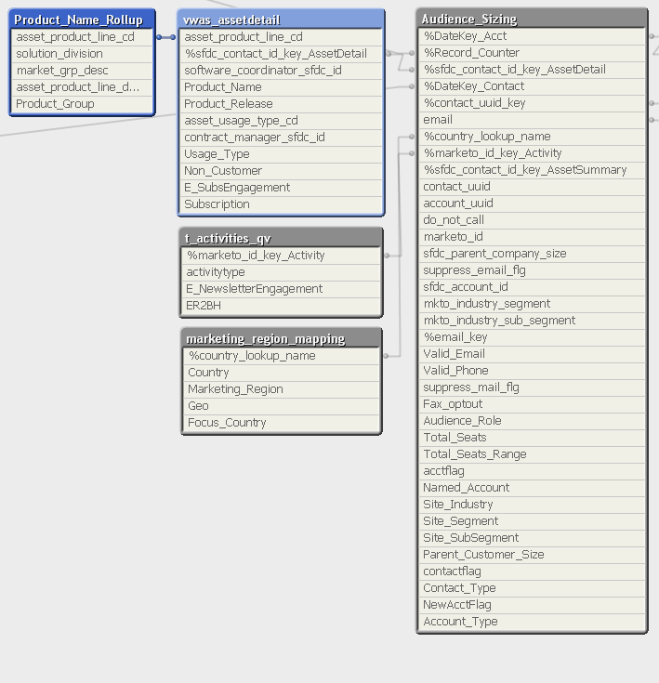

1. **QlikView Script Logic**

Futher details of your Script logic, could be placed here

Some examples could be:

<include files>

<Variables>

<mapping tables>

Listing all your “.qvw” files and the resulting “.qvd” files that are being generated.

Example:

**t_contact_account_lead.qvw** → **t_contact_account_lead.qvd**

**ecq_contact_quality.qvw** → **ecq_contact_quality.qvd**

If your tasks follow a waterfall methodology, list that here with a screen shot or a simple description

Tasks list setup in QMC (QlikView Management Console):

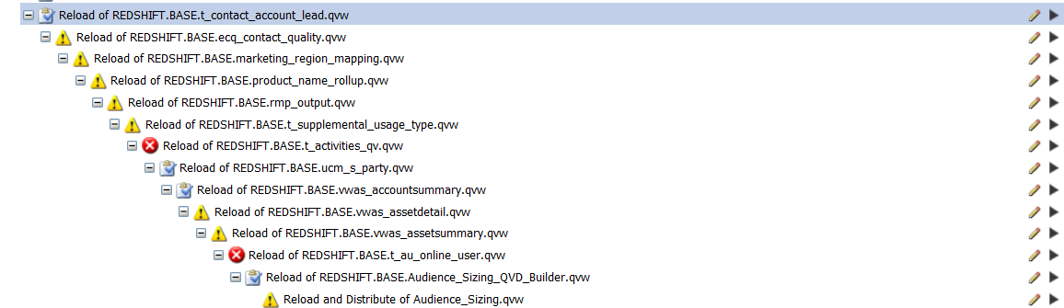

1. **Data Volume**

*<Some info on data volume, ETL extract time, etc are also what I like to put down>*

DataSet: Extract Volume

**Contacts** 9,132,946

**Account** 75,813,678

**Region** 250

Total run time of entire ETL/dashboard refresh process:

Start Time: 5:05 AM

End Time: 8:50 AM.

Approx 4 hours.

1. **Data Integration**

Information on any data dependencies.

*<Optional Section(s)>*

1. **DB Connection String info**

*A QlikView connection string is schema dependent, there are several ways to do this.*

*If you have sepearate connection strings per schema, these would be listed here.*

1. **QLIKVIEW TECHNICAL**

*<A listing of your expressions>*

*<Some examples>:*

Expression for calculating **Total # of Contacts:**

Count( TOTAL DISTINCT contact_uuid )

Expression for calculating **Contact Count with Association:**

Count(DISTINCT {< account_uuid = {"*"}>} contact_uuid)

Expression for calculating **Total # of Accounts:**

Count( TOTAL DISTINCT account_uuid)

1. **RISKS / MITIGATION PLAN**

*<A list of things that could go wrong, in causing the dashboard to not re-load>*

1. **LEGEND**

*<Trace back to your Data Model from your UI>*

__________________________________________________________________________________

